File permissions in Linux

Project description
As a part of the research team, I need to make sure the appropriate permissions for authorised users in different groups and keep the system safe and secure. The research team wants to make necessary changes to file permission on the organisation to provide permissions for authorised and unauthorised access.

Check file and directory details
Below screenshot displays how I used the Linux commands to determine the existing permissions set for a specific directory in the file system.

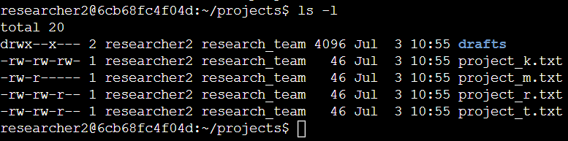

I used ls -la command to display the current permissions for access to files and directories. This command will list the hidden file contents. The output of my command indicates that there is one directory named drafts, one hidden file named .project_x.txt and five other project files. The 10-character string in the first column represents the permissions set on each file or directory.

Describe the permissions string
The 10-character string can be deconstructed to determine who is authorized to access the file and their specific permissions. The characters and what they represent are as follows:
- 1st character: This character is either a d or hyphen (-) and indicates the file type. If it’s a d, it’s a directory. If it’s a hyphen (-), it’s a regular file.
- 2nd-4th characters: These characters indicate the read (r), write (w), and execute (x) permissions for the user. When one of these characters is a hyphen (-) instead, it indicates that this permission is not granted to the user.
- 5th-7th characters: These characters indicate the read (r), write (w), and execute (x) permissions for the group. When one of these characters is a hyphen (-) instead, it indicates that this permission is not granted for the group.
- 8th-10th characters: These characters indicate the read (r), write (w), and execute (x) permissions for other. This owner type consists of all other users on the system apart from the user and the group. When one of these characters is a hyphen (-) instead, that indicates that this permission is not granted for other.

For example, the file permissions for project_m.txt are -rw-r-----. Since the first character is a hyphen (-), this indicates that project_t.txt is a file, not a directory. The second and fifth characters are all "r" which indicates the user and group. The third character "w" indicates only users have write permission. No one has executed permissions for project_m.txt.

Change file permissions
The organization determined that others shouldn't have write access to any of their files. To comply with this, I referred to the file permissions that I previously returned. I determined project_k. txt must have the write access removed for others.

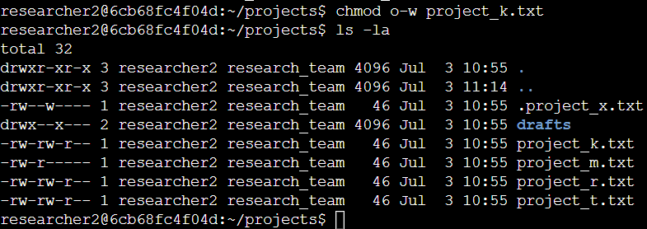

The following command I have entered chmod is used to make changes on the files and directories file project_k.txt. The output of the command shows the changes made on the authorised access. The first two lines of the screenshot display the commands I entered, and the other lines display the output of the second command. The chmod command changes the permissions on files and directories. The first argument indicates what permissions should be changed, and the second argument specifies the file or directory. In this example, I removed write permissions from others for the project_k. txt file. After this, I used ls - la to review the updates I made.

Change file permissions on a hidden file
Since the research team recently archived file project_x.txt, they do not want anyone to have write access to this project. However, the user and group should have read access.

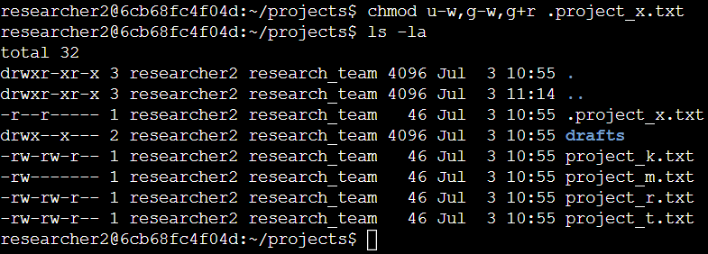

The first 2 lines of code demonstrates how I used linux commands to change the permissions of a hidden file. The rest of the lines display the output of the command of the second line. The ".project_x.txt" is a hidden file as it starts with ( . ). In the above screenshot, I removed write permissions from the user and group, and added read permission to the group. I removed write permissions from the user with u-w. Then, removed write permissions from the group with g-w, and added read permissions to the group with g+r.

Change directory permissions
The organization wants only the “researcher2” team to have the authorization to access the "drafts" directory and its contents.
This means that the execute permissions should be with the researcher2 only.

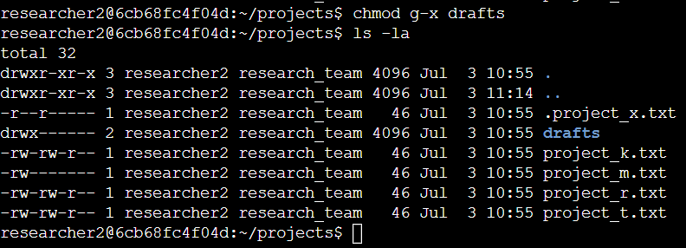

The output shows the permission listing for several files and directories. The line 1 and 2 indicates current directory (projects) and parent directory (home). From line 3, indicates regular files listed. We can see that only researcher2 has execute permissions. The researcher2 user already had execute permissions. so they did not need to be added.

Summary
To match the level of authorization my organisation wanted for the files and directories in the "projects" directory. I have listed permissions for the files and directories using the command "ls -la". Then I have used the "chmod" command multiple times to change the permissions on files and directories.

